1. **AIO-3399ProC Six-core High-performance AI Main Board**

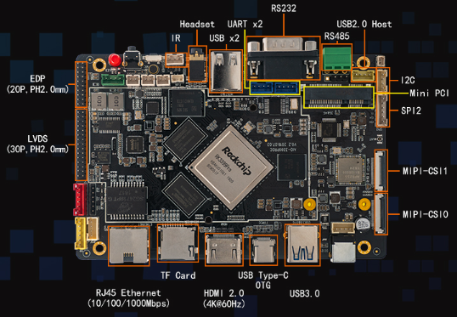

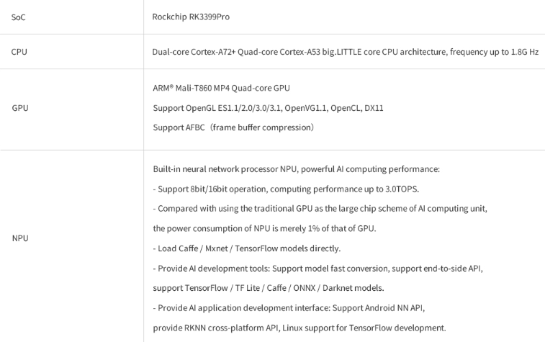

Reference link: <https://www.firefly.store/goods.php?id=109>

1. **AIO-3399C（AI）**

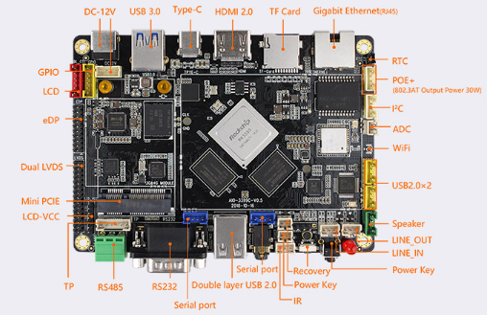

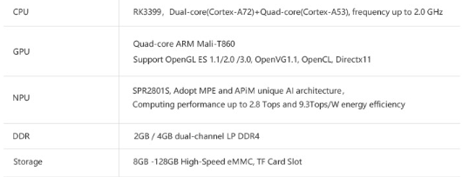

Reference Link: <https://www.firefly.store/goods.php?id=96>

1. **ROC-RK3588S-PC**

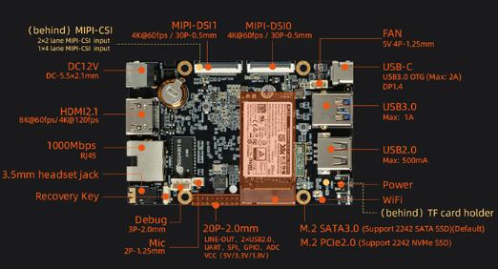

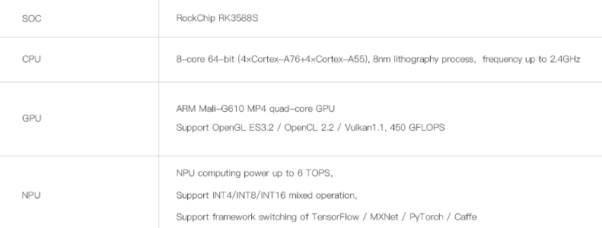

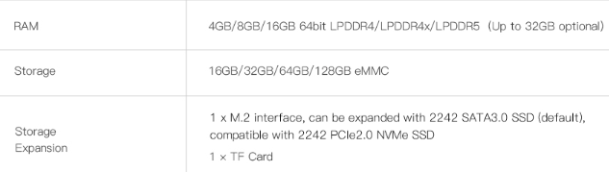

**Reference Link:** [**https://www.firefly.store/goods.php?id=163**](https://www.firefly.store/goods.php?id=163)

1. **EC-A3399ProC Six-core 64-bit AI Embedded Computer**

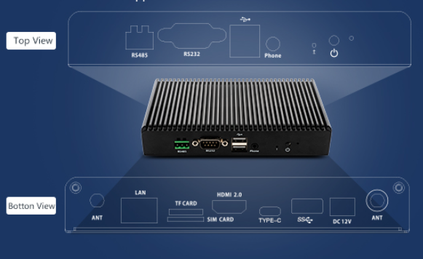

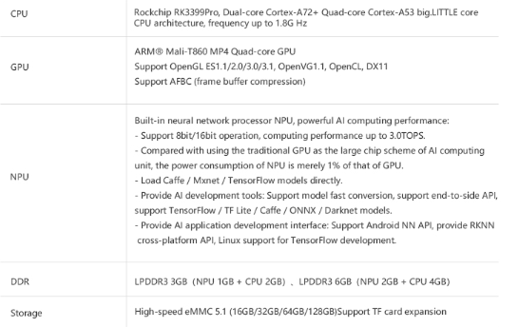

**Reference Link:** [**https://www.firefly.store/goods.php?id=110**](https://www.firefly.store/goods.php?id=110)

1. **ITX-3588J 8K AI Mini-ITX Mainboard**

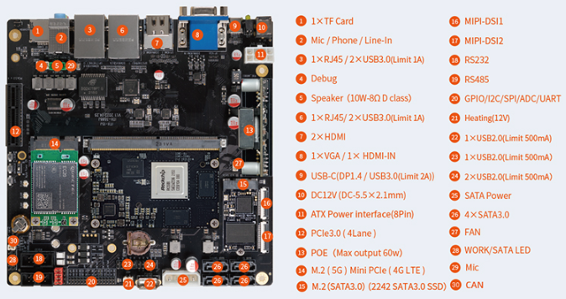

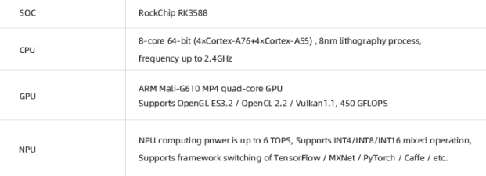

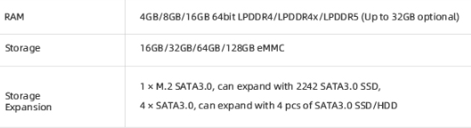

**Reference Link:** [**https://www.firefly.store/goods.php?id=161**](https://www.firefly.store/goods.php?id=161)